Project Planning Phase
Project Planning Template (Product Backlog, Sprint Planning, Stories, Story points)

Date | 26 June 2026
Team ID
Project Name | Leave Approval System
Maximum Marks | 5 Marks

Product Backlog, Sprint Schedule, and Estimation (4 Marks)
Sprint | Functional Requirement (Epic) | User Story Number | User Story / Task |  | Story Points | Priority | Team Members
Sprint-1 | Project Setup | USN-1 | Create scoped application, configure roles (Employee, Manager, Administrator), create Leave Request table and application modules |  | 8 | High
Sprint-2 | Leave Request Management | USN-2 | Develop leave request form, validate leave details, create Business Rules, allow employees to submit leave requests |  | 9 | High
Sprint-3 | Approval Workflow & Notifications | USN-3 | Manager approval/rejection, Flow Designer automation, email notifications, update leave status |  | 8 | High
Sprint-4 | Testing and Documentation | USN-4 | System testing, bug fixes, reports, final documentation, presentation preparation |  | 5 | High

Project Tracker, Velocity & Burndown Chart: (4 Marks)
Sprint | Total Story Points | Duration | Sprint Start Date | Sprint End Date (Planned) | Story Points Completed (as on Planned End Date) | Sprint Release Date (Actual)
Sprint-1 | 8 | 2 Days | 22 June 2026 | 23 June 2026 | 8 | 23 June 2026
Sprint-2 | 9 | 2 Days | 24 June 2026 | 25 June 2026 | 9 | 25 June 2026
Sprint-3 | 8 | 2 Days | 26 June 2026 | 27 June 2026 | 8 | 27 June 2026
Sprint-4 | 5 | 1 Day | 28 June 2026 | 28 June 2026 | 5 | 28 June 2026

Velocity:

- Total Story Points: 30
- Total Duration: 7 days
Average Velocity = 30 ÷ 7 ≈ 4.3 story points/day

Burndown Chart:
A burn down chart is a graphical representation of work left to do versus time. It is often used in agile software development methodologies such as Scrum. However, burn down charts can be applied to any project containing measurable progress over time.
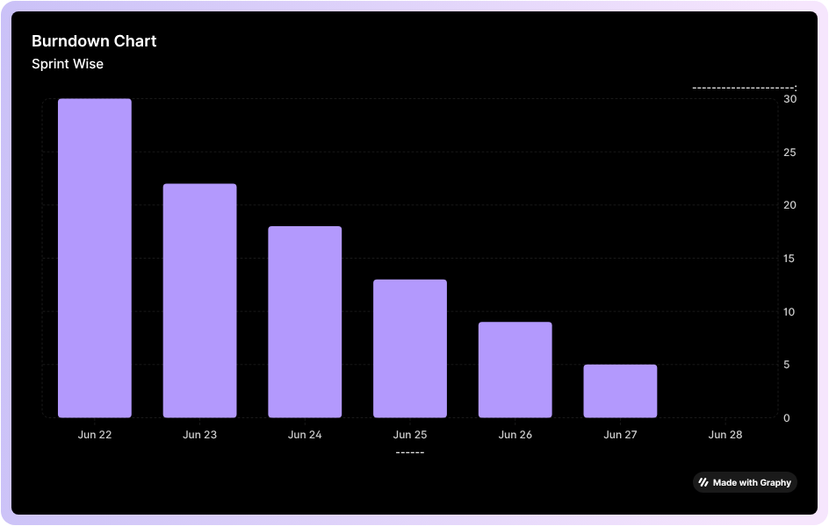

https://www.visual-paradigm.com/scrum/scrum-burndown-chart/
https://www.atlassian.com/agile/tutorials/burndown-charts

Reference:
https://www.atlassian.com/agile/project-management
https://www.atlassian.com/agile/tutorials/how-to-do-scrum-with-jira-software
https://www.atlassian.com/agile/tutorials/epics
https://www.atlassian.com/agile/tutorials/sprints
https://www.atlassian.com/agile/project-management/estimation
https://www.atlassian.com/agile/tutorials/burndown-charts

